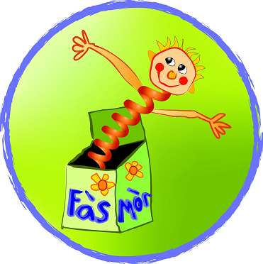
Basgaid Ionmhais is ‘Heuristic play’

Tha sinn a’ feuchainn ri stuth a chruinneachadh airson basgaid ionmhais agus ‘heuristic play’.
We are trying to gather things/materials for our treasure basket and heuristic play.

A’ mhìos seo tha sinn a’ coimhead airson stuth fiodha:
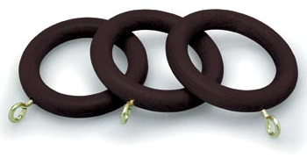

lùban fiodha

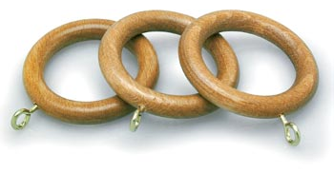
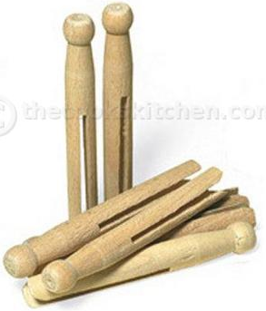

Biorran aodaich
(fiodha)

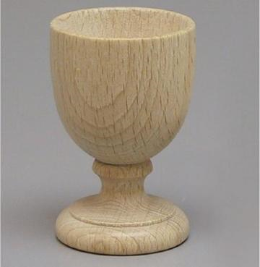

glain'-uigh (fiodha)

Basgaid Ionmhais is ‘Heuristic play’

Tha sinn a’ feuchainn ri stuth a chruinneachadh airson basgaid ionmhais agus ‘heuristic play’.
We are trying to gather things/materials for our treasure basket and heuristic play.

A’ mhìos seo tha sinn a’ coimhead airson stuth fiodha:

lùban fiodha

Biorran aodaich
(fiodha)

glain'-uigh (fiodha)

